

SELF-INJECTION GUIDE: INTRAMUSCULAR (IM) vs SUBCUTANEOUS (SUBQ)

Use these instructions to properly administer injectable testosterone medication. You should always follow the dosing schedule provided and consult with Dr. Ehrlich if you have any questions about proper administration, dosage, or side effects.

General Safety Principles
- Wash hands thoroughly before handling supplies.
- Use a new, sterile needle and syringe for each injection.
- Clean the injection site with an alcohol swab and allow to dry.
- Do not inject into areas that are red, swollen, painful, or infected.
- Dispose of needles immediately in an approved sharps container.

Option 1: Intramuscular (IM) Testosterone Injection
- What is IM injection? The medication is injected directly into a muscle, where it is slowly absorbed into the bloodstream.
- Common Injection Sites:
  - Gluteus medius (upper outer buttock)
  - Vastus lateralis (outer thigh)
  - Deltoid (upper arm, less commonly used)
- Recommended Needle and Syringe:
  - Syringe: 1 – 3 mL
  - Drawing Needle: 18 – 21 gauge (optional, for vial only)
  - Injection Needle: 22 – 25 gauge
  - Needle length: 1 inch for thigh or deltoid, 1 – 1.5 inches for gluteal
- Common Side Effects:
  - Muscle soreness at injection site
  - Bleeding or bruising
  - Temporary discomfort

Option 2: Subcutaneous (SubQ) Testosterone Injection?
- What is SubQ injection? The medication is injected directly into the fatty layer of tissue just under the skin. Most commonly in the abdomen.
- Recommended Needle and Syringe:
  - Syringe: Insulin syringe
  - Needle: 27 – 30 gauge
  - Needle length: 0.5 inch
- Common Side Effects:
  - Mild redness or itching
  - Small, temporary nodules under the skin
  - Rare local irritation

Key Differences between IM and SubQ injections :

Feature | IM Injection | SubQ Injection
Needle Size | Larger | Smaller
Injection Depth | Muscle | Fatty Tissue
Comfort | Moderate | Usually Better
Testosterone Level Swings | Higher | Lower
Injection Frequency | Weekly or Biweekly | Weekly or Split Dose

Injection Instructions:
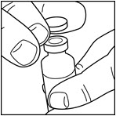
- Remove the protective cap of the vial, leaving the stopper in place.

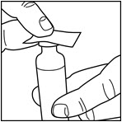
- Wipe the top of the vial with an alcohol swab.

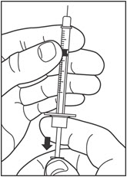
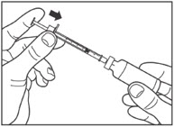
- Draw air into the syringe equal to your dose. Put the needle through the rubber top of the vial and push the plunger to inject the air into the vial.

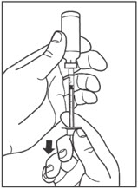
- Leave the syringe in the vial and turn both upside down. Hold the syringe and vial firmly in one hand. Make sure the tip of the needle is in the medication. With your free hand, pull the plunger to withdraw the correct dose into the syringe.

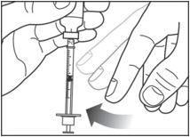
- Before you take the needle out of the vial, check the syringe for air bubbles. If bubbles are in the syringe, hold the syringe straight up and tap the side of the syringe until the bubbles float to the top. Push the bubbles out with the plunger and draw medication back in until you have the correct dose.

- Remove the needle from the vial. Do not let the needle touch anything.
You are now ready to inject.

- Choose your injection site: testosterone is injected intramuscularly in the buttocks or thigh or subcutaneously in the abdomen.
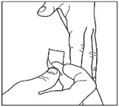
  - Change (rotate) your injection sites within the area you choose for each dose to reduce your risk of getting pits in the skin or thickened skin (lipodystrophy) and skin with lumps (localized cutaneous amyloidosis) at the injection sites.
  - Do not inject where the skin has pits, is thickened, or has lumps.
  - Do not inject where the skin is tender, bruised, scaly or hard, or into scars or damaged skin.
  - Wipe the skin with an alcohol swab to clean the injection site. Let the injection site dry before you inject your dose.

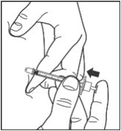
- Inject the medication:
  - If injecting Sub Q, pinch the skin.
  - Insert the needle in the way your healthcare provider showed you.
  - Release the skin.
  - Slowly push in the plunger of the syringe all the way, making sure you have injected all of the medication
  - Leave the needle in the skin for about 10 seconds.

- Remove and dispose of the needle.
  - Pull the needle straight out of your skin.
  - Gently press the injection site for several seconds. Do not rub the area.
  - Safely dispose of the needle.



